**THE DIGITAL MULTIMETER**

The goal of these laboratory experiences is for us to become familiar with the Digital Multimeter to measure Resistance, Voltage and Current.Besides, we will become familiar with the solder-less breadboard used for prototyping.

1.- Digital Multimeter as an Ohmmeter: Measure Resistance

The picture below depicts a Digital Multimeter (DMM) similar to those that we will use in the labs in this course.

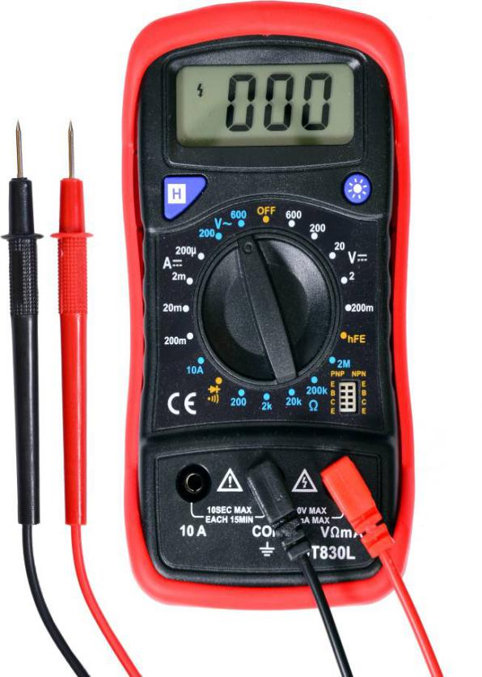

The central the rotary knob is used to select the variable to

measure: Ohms, AC Volts, DC Volts, AC Amperes, DC Amperes, Temperature, and Gain of Transistors, among other variables.

Procedure for Measuring Resistance:

The central the rotary knob is employed to pick the variable to  
measure: Ohms, AC Volts, DC Volts, AC Amperes, DC Amperes, Temperature, and Gain of Transistors, among alternative variables.  
  
Procedure for activity Resistance:  
1a.- make sure that the ability within the circuit  is OFF.  
Ohmmeter applies external current. It will act with the ability within the circuit and injure it. or

1b.- Remove the component from the circuit

2.- Connect Black lead to COM

3.- Connect Red lead to the terminal with symbol Ω

4.- Move Rotary selector to Ω

5.- Value of display is Resistance

6.- If the display shows “OL”: Overload. Select a higher range

Procedure for Measuring Voltage:

1.Turn the dial to ṽ. If voltage in the circuit is unknown, set the range to the highest voltage setting and set the dial on ṽ.

2.First insert the black lead into the COM jack.

3.Next insert the red lead into the VΩ jack. When finished, remove the leads in reverse order: red first, then black.

4.Connect the test leads to the circuit: black lead first, red second.**Note:** ac voltage does not have polarity.

Read the measurement in the display. When finished, remove the red lead first, black second.

Procedure for Measuring Current:

1. Turn the meter on
2. Insert the probes into the correct connections.
3. Set main selector switch on the meter switch to the current and range for the measurement to be made. When selecting the range, ensure that the maximum range is above the expected reading anticipated.
4. Connect the test leads to the circuit: black lead first, red second.

Read the measurement in the display. When finished, remove the red lead first, black second.

**BREADBOARD**

The figure below shows a picture of a solderless breadboard.

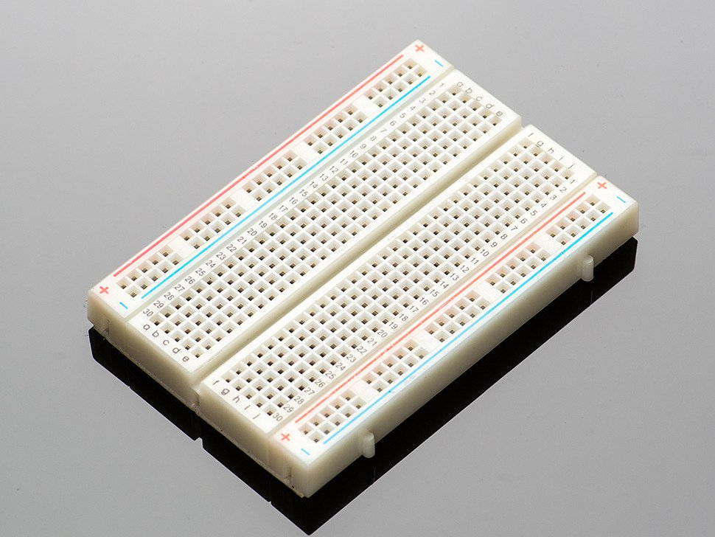

Each pin is interconnected to alternative pins as shown in some breadboards, the correct and left facet of the horizontal pins of rows don't seem to be connected to the horizontal lines square measure generally reserved for power provide voltages, grounds, The vertical lines square measure generally used for interconnecting parts.

For those new to circuits, breadboards are simplest place to begin. That's the  great thing about breadboards-they can house both the simplest circuit as well as very complex circuits. If ourcircuit outgrows its current bread board, others is be hooked up to accommodate circuits of all sizes and complexities.

Another common use of breadboards is testing out new components, like Integrated circuits (ICs). once you are attempting to work out however a part works and perpetually rewiring things, you don’t wish to own to solder your connections everytime. For this breadboards are best suited as they need not be soldered and we can break the connection whenever we want.